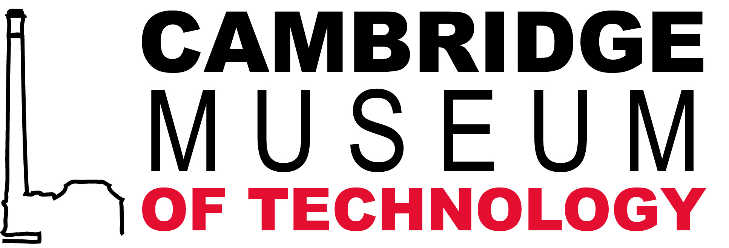

Cambridge Museum of Technology – Education Volunteer

Cambridge Museum of Technology is an independent museum based in the city’s former sewage pumping station. Its collections range from 19th -century steam engines to 20th -century scientific instruments and telecommunications equipment, all with a strong local connection.

We have been awarded a major grant from the Heritage Lottery Fund to transform the museum. The redevelopment will include creating new displays about local industries and technology, repairing our historic boiler to run the steam engines, and improving visitor facilities and disabled access. There will also be a full programme of events and activities for all ages.

The museum’s new education programme aims to ‘Inspire Learning for All’ by using our historic site and collections to explore the story of waste disposal, public health, social history and the development and use of technology. Participants in our education programme range from pre-schoolers, school aged learners to adult visitors; we aim to provide a programme that has something of interest for everyone. More information about the ‘Inspiring Learning for All’ framework can be found @ https://www.artscouncil.org.uk/sites/default/files/S2D12_Detailed_framework.pdf

We are looking for volunteers to:

- Be involved in preparing learning sessions and supporting materials
- Help set-up sessions before groups arrive
- Help deliver sessions and presentations to children and adults

Our education volunteers need to be:

- Outgoing and sociable
- Interested in people
- A team player
- Have an interest in how learning happens

As an education volunteer you will have the opportunity to take part in:

- The new education programme at the redeveloped Cambridge Museum of Technology
- Workshops in the community and at the museum
- Sessions in local schools and afterschool clubs.
- Delivering school assemblies.
- Our ‘So you want to be an engineer’ summer school
- Cambridge Science Festival (Cambridge University)
- Festival of Ideas (Cambridge University)
- Twilight at the Museums (Cambridge University)
- Summer at the Museum (Cambridge University)
Education volunteers will receive training on:

- How to facilitate sessions working with small groups of children
- Written presentation skills
- Verbal presentation skills

What you will gain:

- Experience and greater confidence in working with children as individuals and in groups
- Experience and greater confidence in working with other adults
- Organisational skills
- Presentation and guidance skills
- New perspectives on the museum and its work
- Experience of working with children and young people
- CV building (and possible reference)

Volunteers involved in session delivery will be required to undergo an enhanced DBS check. There is no fee for this service.

How to apply:
Please complete our Expression of Interest form (http://www.museumoftechnology.com/volunteering/) and send it to info@museumoftechnology.com. Please include details of your previous work experience, the age group you are interested in working with, and the type of activities you would like to be involved in, e.g. preparation, delivery, etc. The posting will remain open until the positions have been filled.

